COSC 2006 Assignment 1
Michael Buffone – 9/15/2019
Test Data

There are two parts of the test data. First, the bank.txt file that you must use to read the data that you will be processing. This file is organized as stated in the assignment document. If on your chosen platform you see any strange characters in this file, you may edit them out. However, in NO way may you change the overall format of the file or the other order of the data itself.

The queries you must perform on the file are as follows. There are no typos here, any errors must be handled in your program by printing an appropriate message.
- perform an S command, with 275 for the account number, and X for the account type
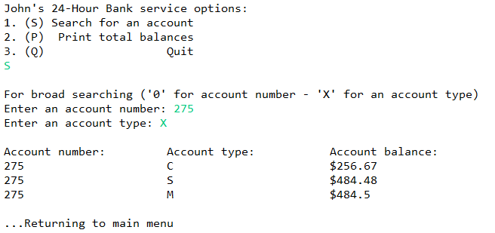

- perform an S command, with 384 for the account number, and X for the account type
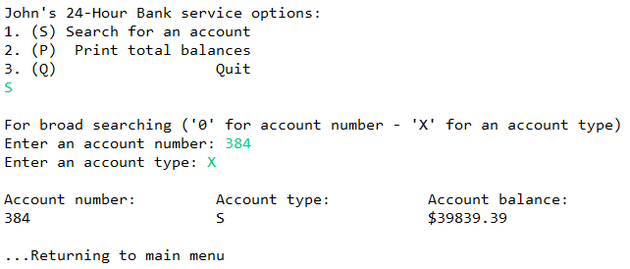
- perform an S command, with 6 for the account number, and X for the account type
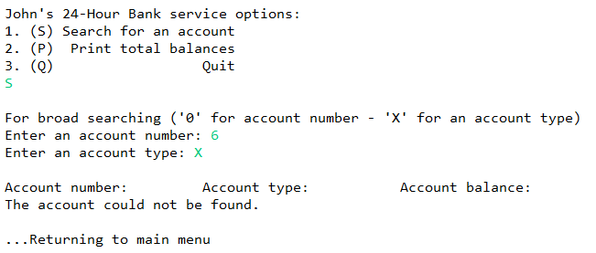

- perform an S command, with 1234 for the account number, and S for the account type
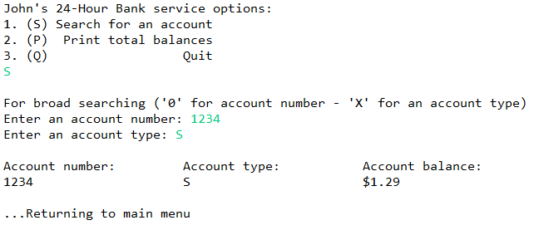

- perform an E command (i.e. enter E when prompted for a command)
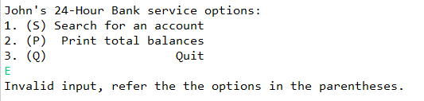

- perform an P command,
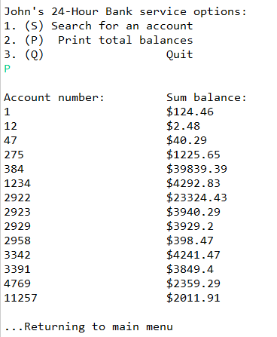

- perform an S command, with 0 for the account number, and C for the account type
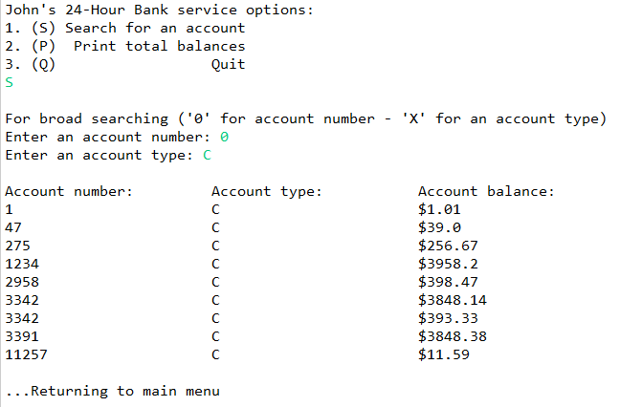

- perform an S command, with 0 for the account number, and M for the account type
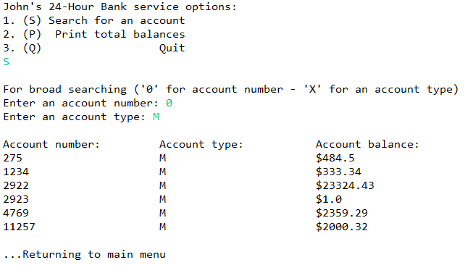

- perform an Q command to quit the program
